**Lab Assignment 3**

**Team : 5**

Kiran Rao Boinapally – class ID : 3

Sai Srinivas Vidiyala – class ID : 29

**Video Link :**

**Link1 :** <https://youtu.be/9H2jaO2cwCQ>

**Link2** : Android login output

<https://drive.google.com/open?id=1UiUo-MsZzwvaDcYiu1NKu0bjVQcfLb8G>

**Introduction** :

1). We are developing an application to get the friends list of the twitter account using twitter API and the authorization key encoded from the base64encode and visualizing them using D3.js.

2). We developed an android app Containing features like login, signup, and social login.

**Objective** :

1). In the twitter friendslist application, we written the code in angular.js and express.js and visulaizing the application using D3.js.

2). In this, we developed android app having signup having user details, Login using registered details , It is having Facebook login.

**Task 1:**

Initially we are importing all the required libraries like jquery, bootstrap, angular js and css and D3.js.

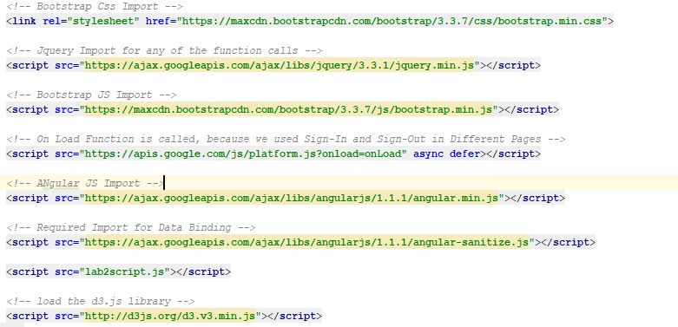

In order to get the authorization key, initially we created an app from this site <https://dev.twitter.com/apps/new>

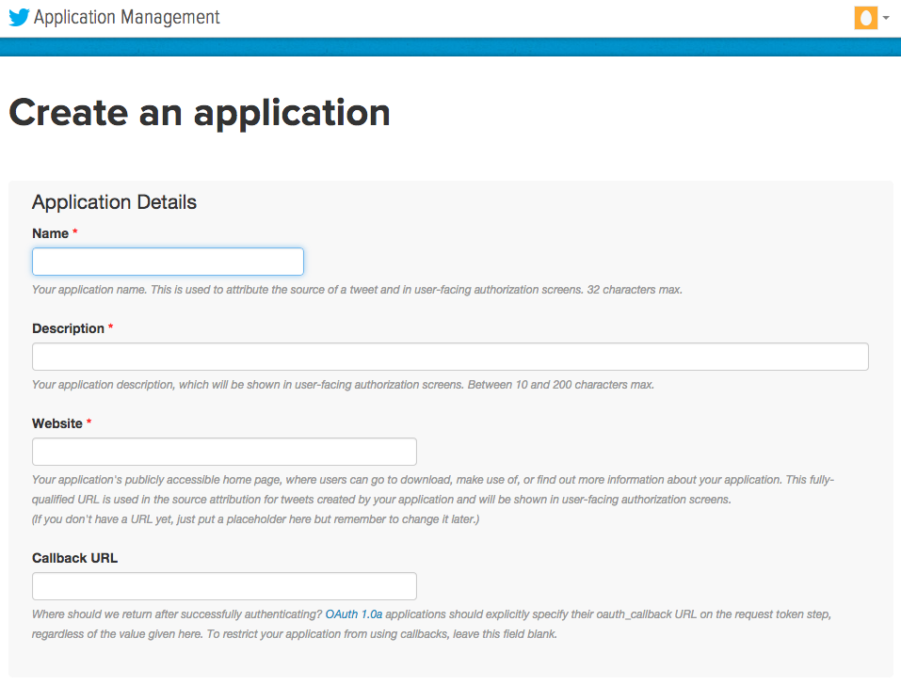

##### In the above website, we created an app and generated the consumer API keys and Access token & access token secret.

##### 

##### Using the below consumer API keys, we generated authorization key from the base64encode.org website

##### We used the above consumer API keys and pasted them in the text box as shown in the below figure in base64encode.org.

##### 

Clicking on the encode button, it generates an encoded key .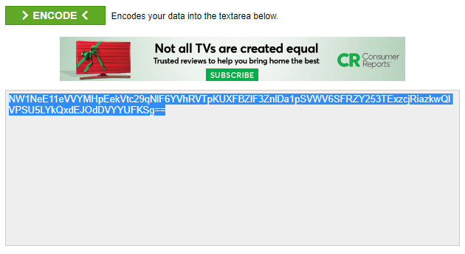

We used that encoded key in the apitester.com and generated the authorization key.

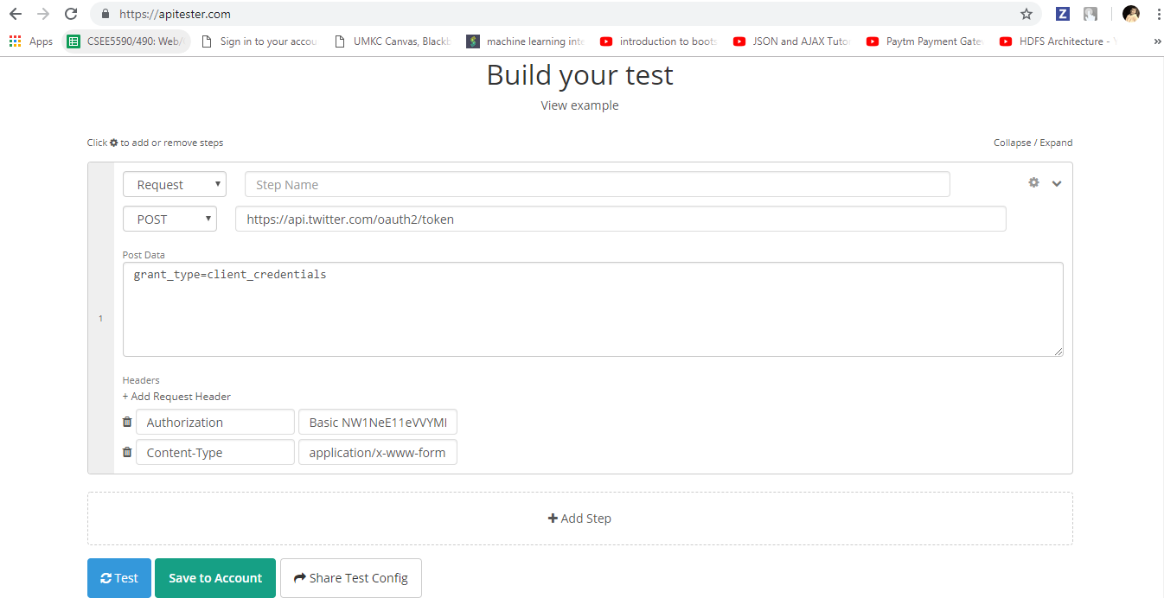

The following picture shows the generated authorization key.

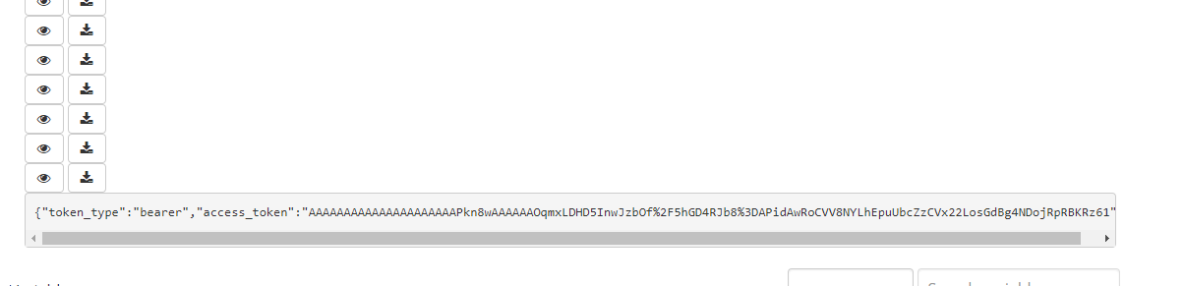

We used the twitter API format to get the twitter friendslist and the above authorization key in the express.js file.

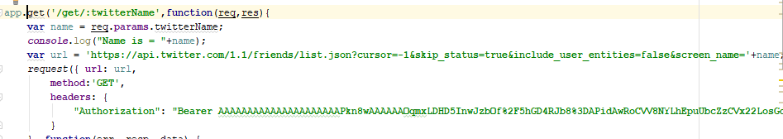

Imported the modules required for express.js. We installed the body-parser module and the request module. These are the following commands.

Npm install body-parser

Npm install request

If the input fields is empty, it throws the following error.

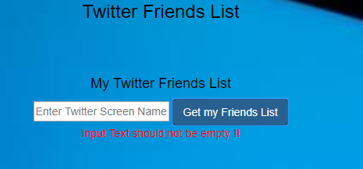

The following code is written to through an error if the input is empty.

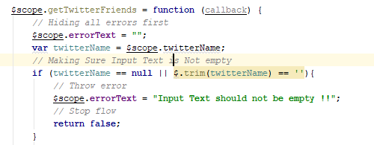

If there is no existing username in the twitter, it throws the error as shown below.

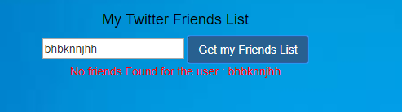

Following is the code for visualizing the twitter friends list using D3.js

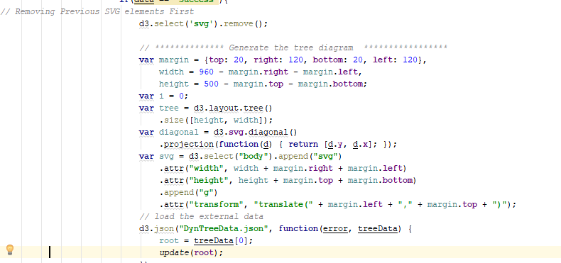

On entering the username of the twitter account in the input field, we get the twitter friendslist and we have done the visulaization using D3.js

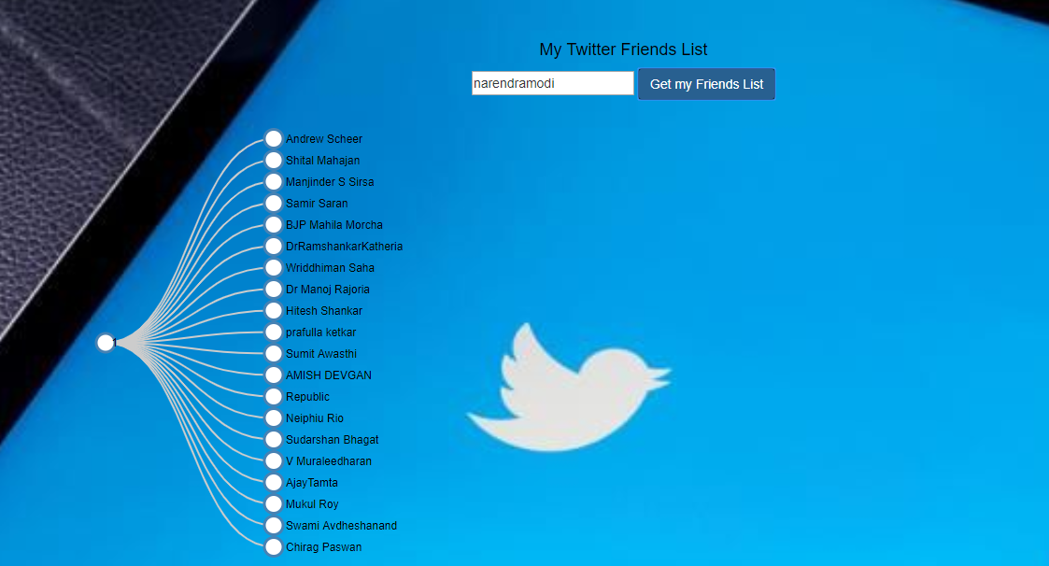

**Task : 2**

Created app

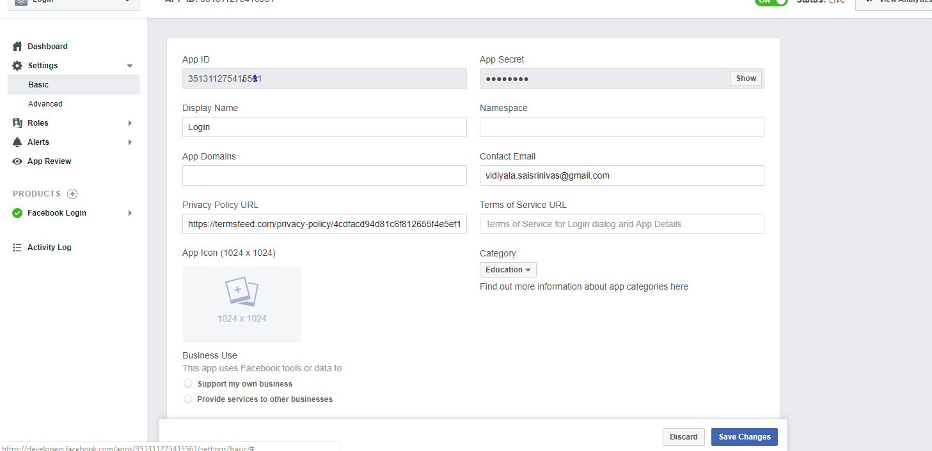

Added hash key , Package name to app

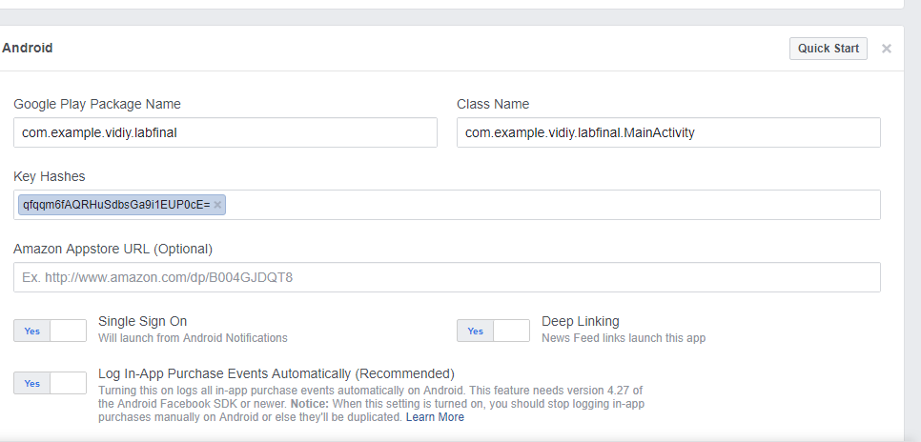

Enabled to public

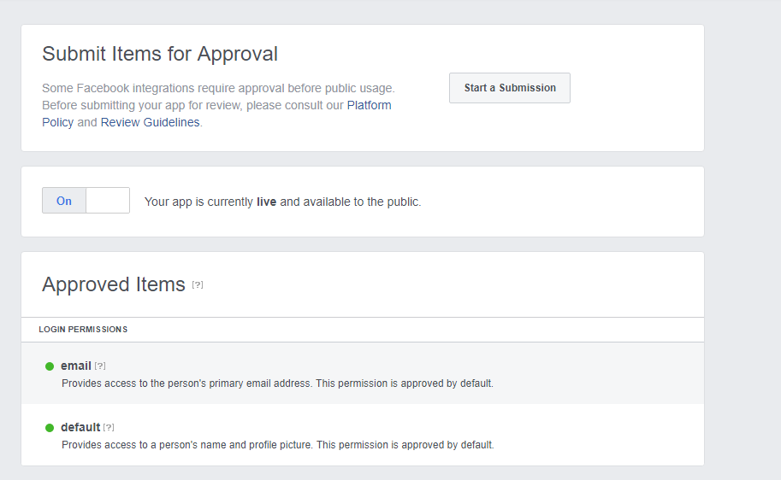

We created our main activity ,we initialised variables

If user press Signup then onclick will be called and then it navigates to registerActivity

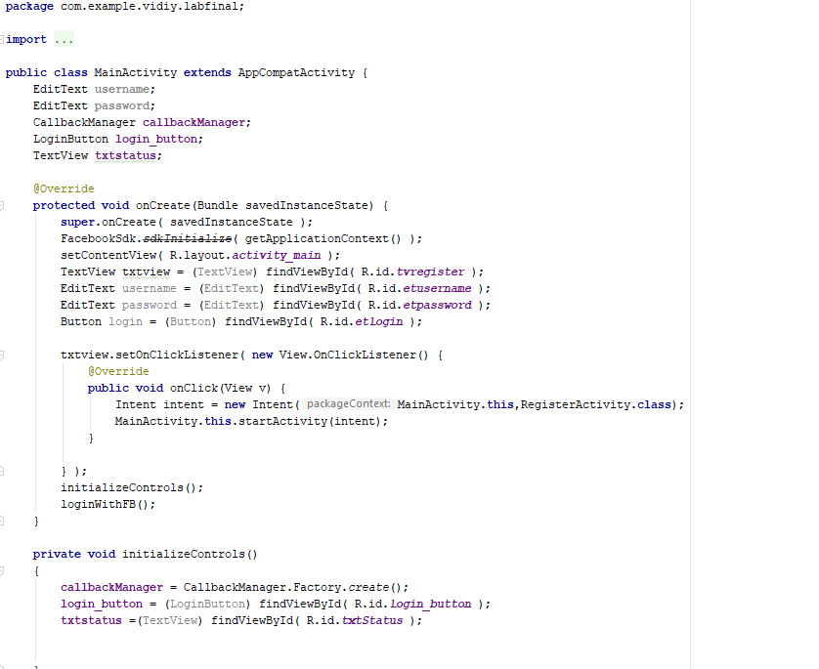

If we click Fb button then below code will be called

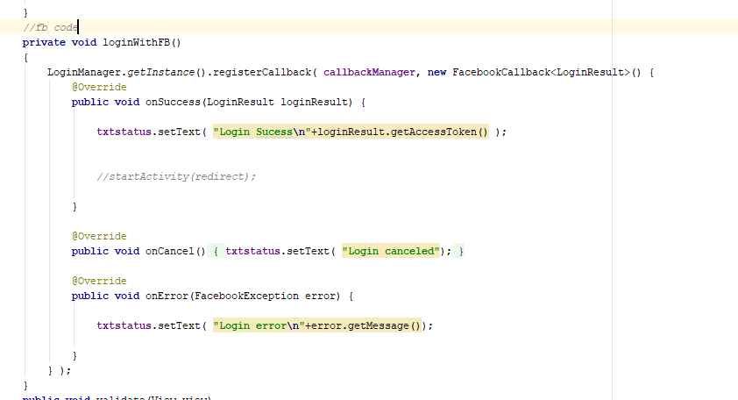

If user press login then validate method will be called

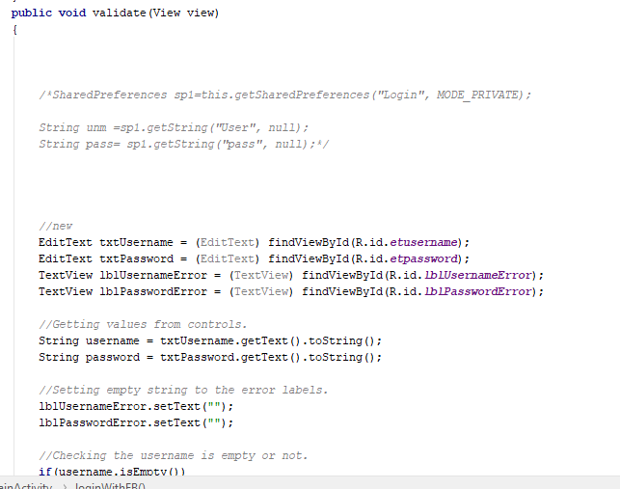

If user presses the register button in signup page, then register method will be called

And data is stored using shared preferences

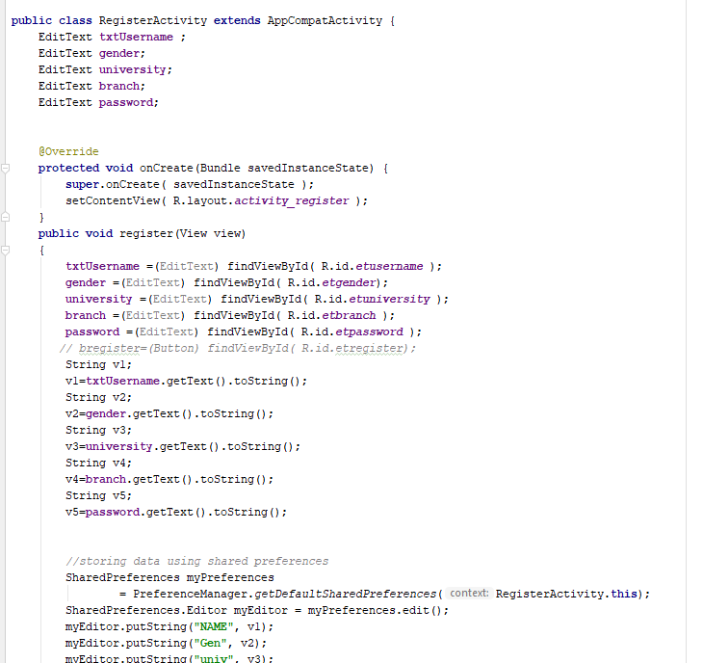

When registration is successful then page is navigated to SucessActivity class

If user presses login button ,then it will be navigated to mainActivity

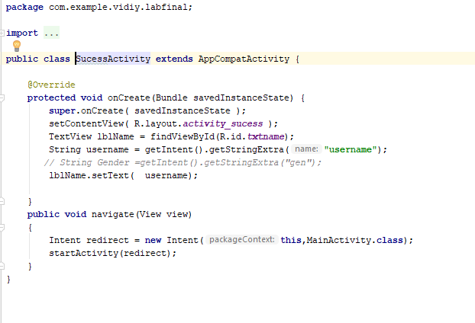

If the user successfully logined , then Welcome Activity will be called

Displaying user details

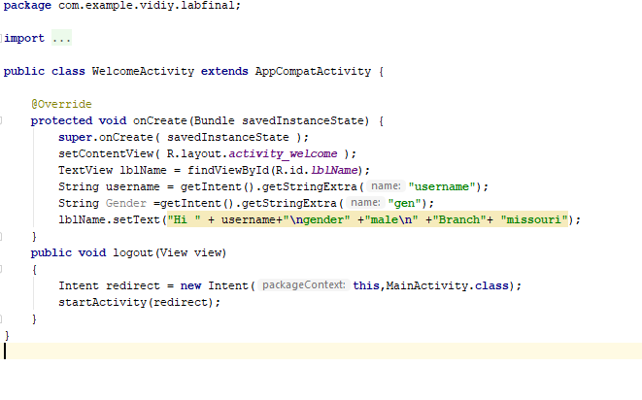

Manifest file , We added fb code also

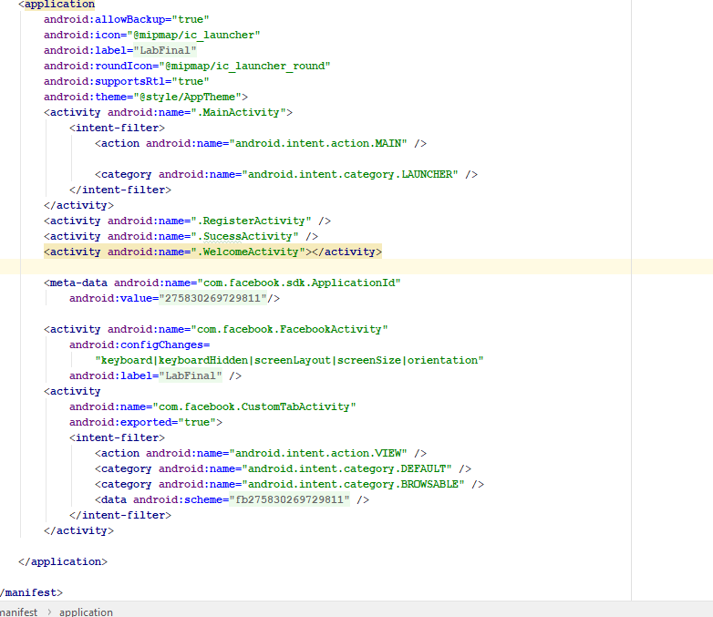

Explaining with UI

When user doesn’t enters username and clicks login

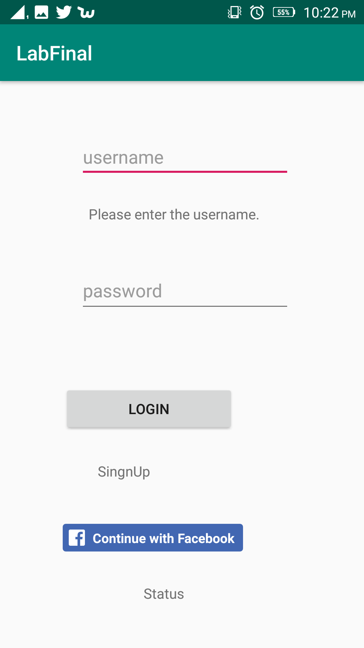

When no password

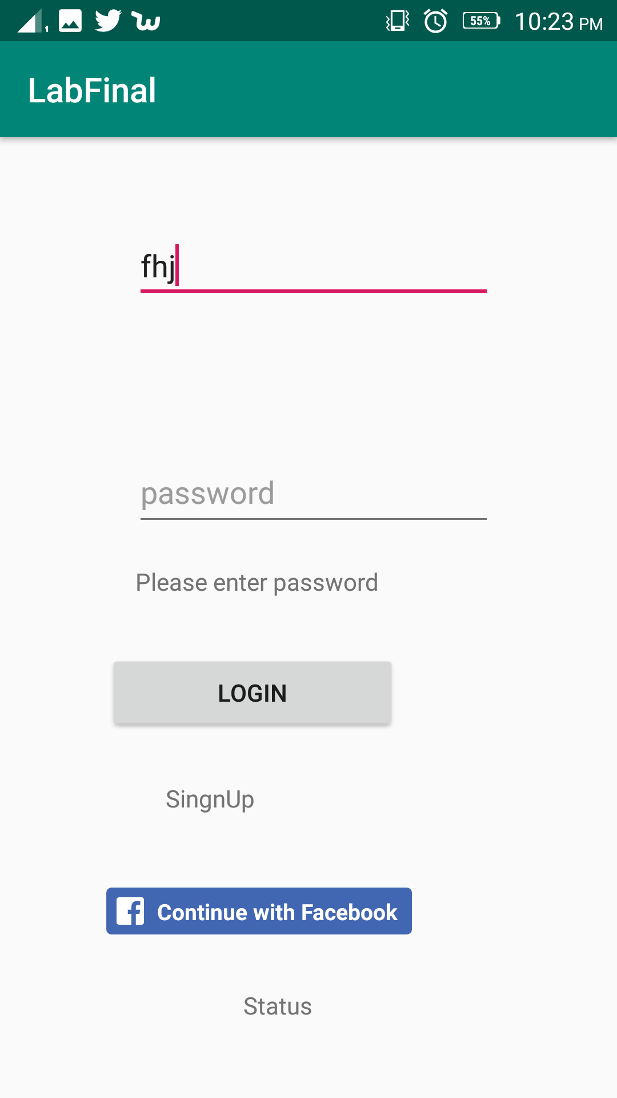

User clicks Sinup

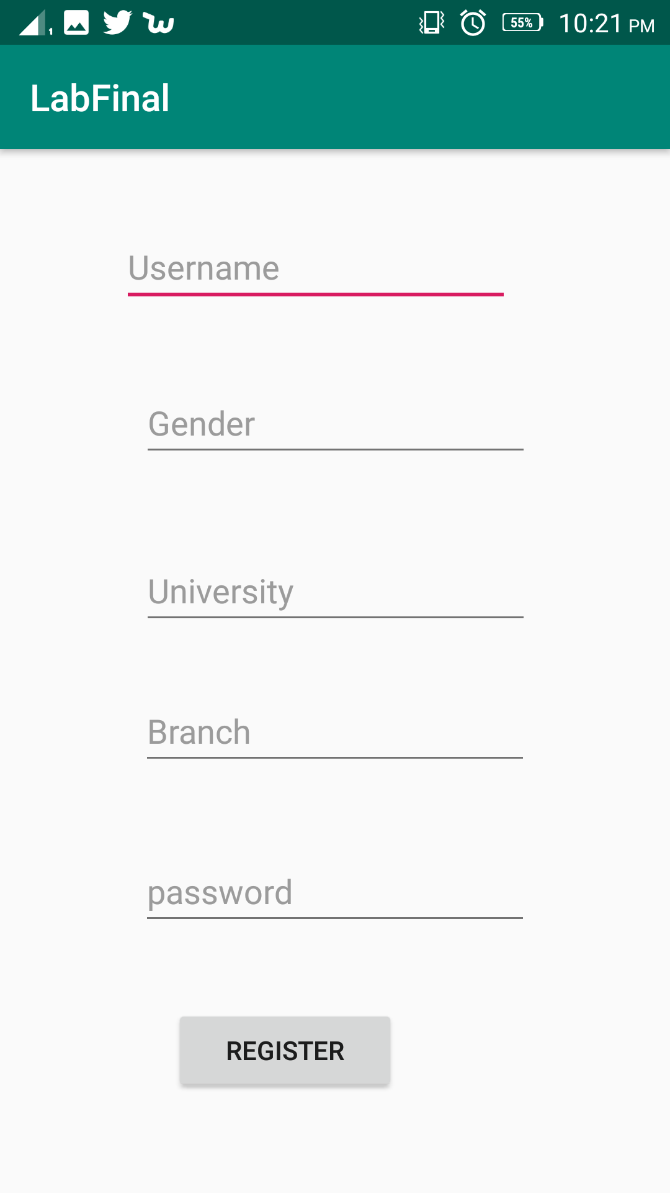

After that Clicks Register

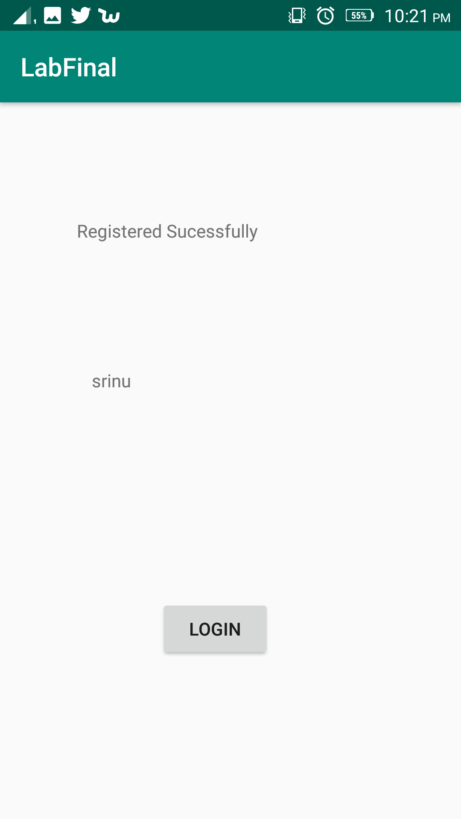

Then Click Login ,Goes to login page



Click on fb button

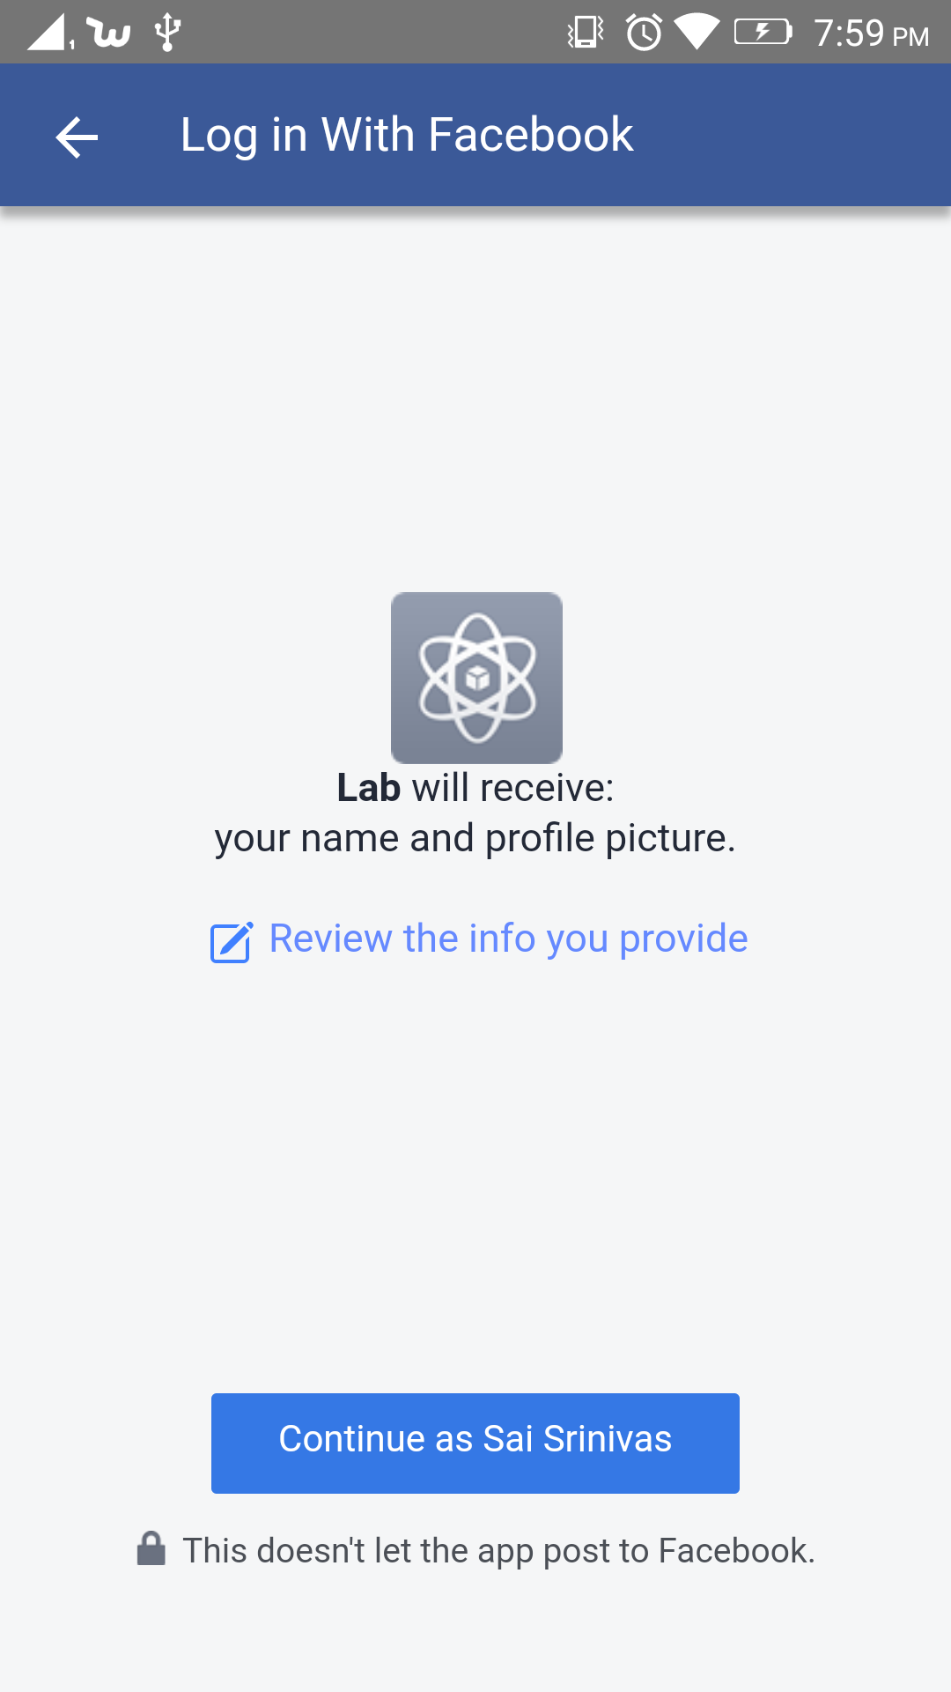

After Logging with user details ,if they are valid

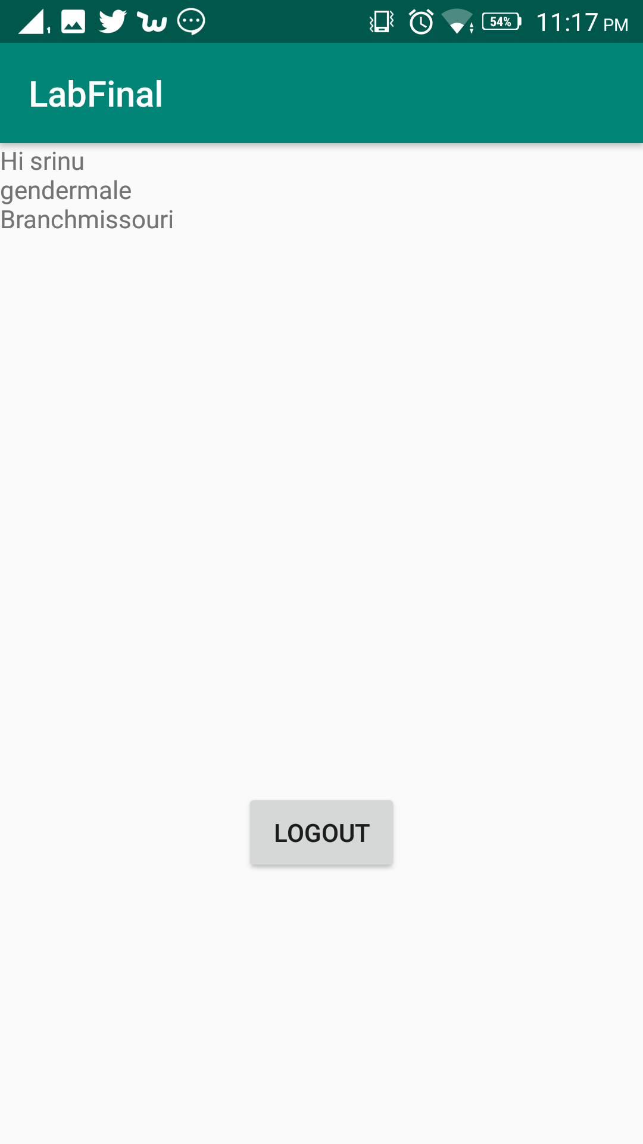

**References :**

[**www.stack.overflow.com**](http://www.stack.overflow.com)

[**www.youtube.com**](http://www.youtube.com)

[**https://developer.twitter.com/content/developer-twitter/en.html**](https://developer.twitter.com/content/developer-twitter/en.html)

[**https://developers.facebook.com/**](https://developers.facebook.com/)